SF213505A
Dual temperature and dual control Laser cooler controller

Instruction manual

Before installing and using the controller, read the instruction manual 2022-06-13
Software version：X1.AC060B.F21.002-1.V140F01
All rights reserved, reprints must be investigated
Contents

1 usage notice 1
2 Specification 1
3 Installation instructions 1
3.1Panel diagram 1
3.2 Electrical connection diagram 2
3.3 Installation size chart 3
4 Operating instructions 4
4.1 Panel description 4
4.2 Boot display 4
4.3 Temperaturen display 4
4.4 Fault display 4
4.5 Modify setting temperature 4
4.6Parameter Setting 5
5 control logic 6

2 Specifications
No | specification parameter | specification |  | No | specification parameter | specification
1 | Power | 220V/AC±10% 50/60HZ |  | 6 | on-off output | 4 relays
2 | Meameasuring temperature range | -40～100℃ |  | 7 | On-off input | 4 Passive signal input
3 | measurement accuracy | 0.1℃@25℃ |  | 8 | analog input | 2 channels NTC temperature probe
4 | working environment | -10℃～60℃，≤85%RH
5 | Storage Environment | -20℃～70℃，≤85%RH

3 Installation instructions

3.1 Panel diagram
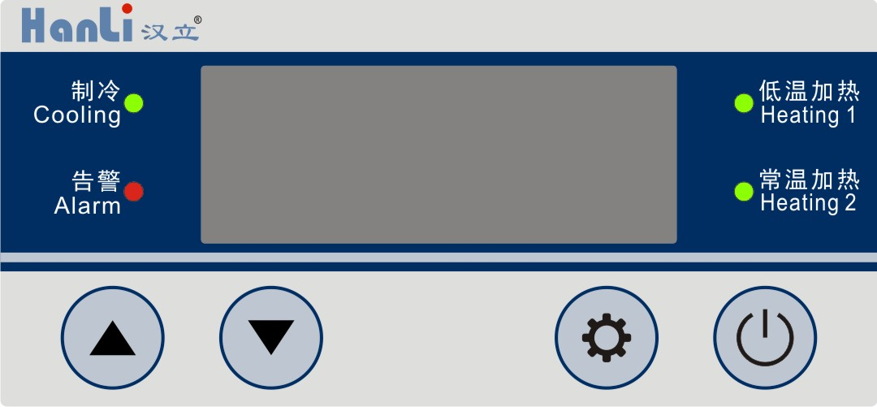

3.2 Electrical connection diagram

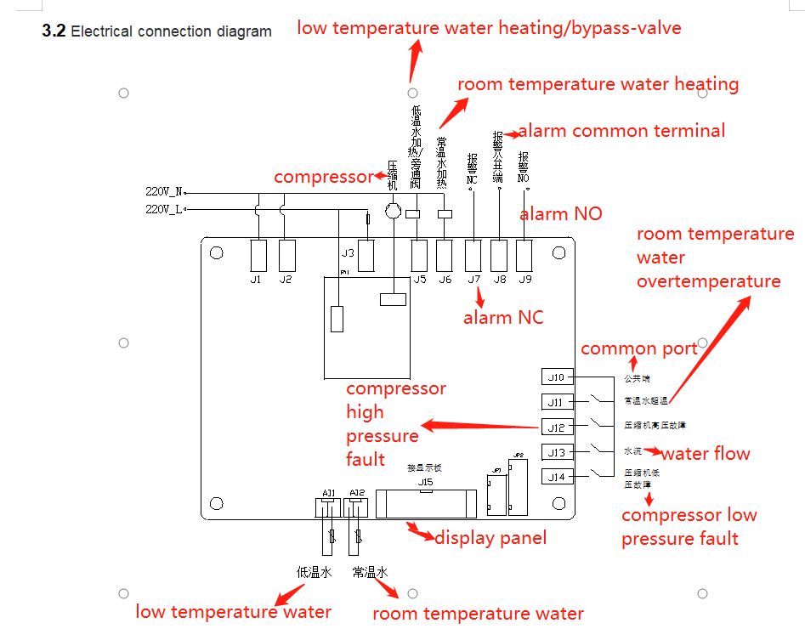

3.3 Installation size chart
Display board：
IO board：
4 Operating instructions

4.1 Panel description

Digital tube | Usage
Display window | Display measuring temperature (low temperature water L.xx.x/room-temperature water H.xx.x) ,setting temperature display (low temperature water S.xx.x/room-temperature water difference d.xx.x) ,alarm code (Exx), parameter code (Fxx).
Indicator light | Usage
制冷（Cooling） | Light on：compressor works； Flicker：There is a demand for refrigeration light off：compressor is off
Low temperature water heating（Heating1） | Light on：low temperature water heating or bypass-valve works； light off：low temperature water heating is or bypass-valve is off；
Room temperature water heating（Heating2） | Light on：Room temperature water heating or bypass-valve works； light off：Room temperature water heating or bypass-valve is off
（Alarm） | Flicker：there is an alarm； light off：no alarm
Keys | Usage
（On/Off） | press < On/Off > for 3 seconds to power On or Off
（Set） | In non-fault state, press <Set> key to enter/exit setting temperature.
Up/Down（▲ ▼） | Modify parameter values during parameter setting.

4.2 Boot display
After the controller is powered on, the display window will display the software version information （Fxx/v140 /Fxx）, and it will enter the temperature display state after about 7 seconds.

4.3 Temperature display

The display window displays the measured water temperature of low temperature water (L.xx.x) by default.

When the temperature is displayed, press the <▼> key to display the normal temperature water measured water temperature (H.xx.x)), the low temperature water set water temperature (S.xx.x), and the normal temperature water set temperature difference (d.xx.x) Switch, 30s without switching operation, it will automatically return to the low temperature water interface.

[Remarks]: L./H./S./d. is the temperature code, xx.x is the temperature value.

4.4 Fault display
When the machine detects a fault, the display window alternately displays the temperature and the fault code "Exx". If there are multiple faults, during alternate display, the next fault will be automatically switched to display. When the fault code is displayed, you can press the <SET> key to silence the fault. The fault codes and descriptions are as follows:

Fault code | Fault name | Fault detection condition | Action | Reset
E01 | Low temperature water probe malfunction | After the machine is powered on, it starts to detect | Alarm, stop the chiller | Manual reset
E02 | Low temperature water high temperature warning | After the machine is powered on, it starts to detect | Alarm, stop heating  （bypass-valve）”； | automatic reset
E03 | Compressor low pressure fault | After the compressor starts running normally, the detection starts after a delay of 2 seconds | Alarm, stop compressor | Manual reset
E04 | Reserved | / | / | /
E05 | Water flow switch alarm | After the machine is powered on, it starts to detect | Alarm, stop the chiller | automatic reset
E06 | Reserved | / | / | /
E07 | Compressor high pressure fault | After the compressor starts running normally, the detection starts after a delay of 2 seconds | Alarm, stop compressor | If the compressor fault occurs for three times within one hour, the automatic reset is maintained for the first two times and manual reset for the third time
E08 | Low temperature Water Low temperature alarm | After the machine is powered on, it starts to detect | Alarm, stop compressor | automatic reset
E09 | Room Water temperature water probe malfunction | After the machine is powered on, it starts to detect | Alarm, stop the chiller | Manual reset
E10 | High temperature alarm of room temperature water | After the machine is powered on, it starts to detect | Alarm, only stop room temperature water and electricity heating | automatic reset
E11 | Low temperature alarm of room temperature water | After the machine is powered on, it starts to detect | Only alarm | automatic reset
E12 | Room temperature electric heating over temperature alarm | After the machine is powered on, it starts to detect | Alarm, only stop room temperature water and electricity heating | automatic reset

[Remarks]：If the fault needs to be reset manually, press <SET> to reset the fault, and it will start automatically after the fault is eliminated.

4.5 Modify setting temperature

In the non-fault state, press the <SET> key at the same time to enter the low temperature water setting temperature setting interface, the set temperature xx.x will flash and display, at this time, you can press the <▲> or <▼> key to modify the set temperature.

After setting, press <SET> or no key operation for 5 seconds, the system will save the set value and exit the setting state.

Normal temperature water setting temperature = [low temperature water setting temperature] + [normal temperature water temperature difference], to modify the factory parameters [normal temperature water temperature difference]

4.6 Parameter Setting
In the temperature display interface, press the <▲>+<▼> keys simultaneously for 5s to enter the factory parameter setting state.
In the process of selecting manufacturer parameters, press <▼> to select parameter items, and press <SET> to enter parameter setting.
When setting the parameters, you can modify the parameter value through <▲> or <▼>. After 5 seconds of no key operation, or press the <SET> key to return to the parameter selection and save (the display window flashes to display the parameter value).
The parameter items and descriptions are as follows:

parameter Item | Parameter function | Factory default | Factory default | Remark
F01 | Room temperature water temperature difference | 3.0℃ | 0.1～20.0℃ | Room temperature water set temperature = [low temperature water set temperature] + [normal temperature water temperature difference]  Not controlled by the upper and lower temperature setting limits  Note: The parameters are invalid at single temperature
F02 | Low temperature water setting temperature | 26.0℃ | 【F06】～【F05】 | For details,pls check the 5 Control Logic.
F03 | Temperature difference of low temperature water loading | 0.5℃ | 0.1～20.0℃ | Low temperature water control temperature difference, when the bypass valve is used, the minimum value of [low temperature water unloading temperature difference] is (F27)
F04 | Temperature difference of low-temperature water unloading | 2.5℃ | 0.1～20.0℃
F05 | temperature setting upper limit | 32℃ | 【F02】～90 ℃ | The settable range of the low temperature water setting temperature
F06 | Temperature setting lower limit | 21℃ | -38～【F02】℃
F07 | Low temperature water over temperature upper limit | 35℃ | 0~99℃ | Alarm when low temperature water temperature is bigger than or equal to this value
F08 | Low temperature lower limit | 2℃ | -38～99℃ | Alarm when low temperature water temperature is smaller than or equal to this value.
F09 | Normal temperature water loading temperature difference | 1.5 | 0.1～20.0℃ | Normal temperature water control temperature difference  Note: The parameters are invalid at single temperature
F10 | Normal temperature water unloading temperature difference | 1.5 | 0.1～20.0℃
F11 | Normal temperature water over temperature upper limit | 40℃ | 0~99℃ | Alarm when the normal temperature water temperature is bigger than or equal to this value  Note: The parameters are invalid at single temperature
F12 | Low temperature water temperature compensation | 0 | -9.9～9.9℃ | Temperature compensation for low temperature water temperature
F13 | Normal temperature water temperature compensation | 0 | -9.9～9.9℃ | Temperature compensation for normal water temperature
F14 | Compressor anti-frequent start time | 90 seconds | 1～255 seconds
F15 | High/low temperature alarm debounce time | 10seconds | 0～255 seconds | After the fault lasts for this time, the fault will be reported
F16 | Water flow alarm debounce time | 2seconds | 1～30 seconds
F17 | Debounce time for high pressure fault of press | 2 seconds | 0～255seconds | After the normal operation of the press starts, the detection starts 2S, and the high pressure fault of the compressor lasts for this time and then alarms.
F18 | compressor high pressure fault | 1 | 0～2 | 0: Normally open 1: Normally closed 2: Disabled  When set to normally open, the switch is closed to alarm  When set to normally closed, the switch is disconnected to alarm  When disabled, the state of the corresponding switch is not detected.
F19 | Flow switch | 1 | 0～2
F20 | Normal temperature and over temperature switch | 1 | 0～2
F21 | compressor low pressure fault | 1 | 0～2
F22 | Incoming call starts automatically | 1 | 0～1 | 0: Not used 1: Used
F24 | Single and double temperature selection | 1 | 0~1 | 0: Single temperature 1: Dual temperature
/ | Compressor start delay | 10 seconds | / | The compressor is not allowed to start until at least this set time has elapsed since the unit started.  Fixed parameters, not adjustable, not selectable
/ | Alarm relay function | 1 | / | 0: means normally open; 1: means normally closed.  Normally open: disconnected when the unit is in normal operation, and closed when there is a fault or standby;  Normally closed: when the unit is in normal operation, it is closed, and it is disconnected when there is a fault or when it is in standby.  Fixed parameters, not adjustable, not selectable
F25 | Delayed to turn off the compressor | 40seconds | 0～255seconds | When [Bypass valve/low temperature water heating] is "1", low temperature water ≤ low temperature water set temperature - [open bypass valve temperature difference] and the duration is [compressor off delay], turn off the compressor
F26 | temperature difference when open the bypass valve | 0.5℃ | 0.1～10.0℃ | Bypass valve to control temperature difference
F27 | temperature difference when close the bypass valve | 0.5℃ | 0.1～10.0℃ | Bypass valve to control temperature difference
F28 | Bypass valve/low temperature water heating | 1 | 0～1 | 0: Low temperature hydroelectric heating  1: Bypass valve
F29 | Alarm temperature difference | 1.0℃ | 0.1～10.0℃ | If the normal temperature water temperature - low temperature water temperature ≤ [alarm temperature difference value], and the duration is 3 minutes, the alarm E11 fault
F30 | Continuous debounce time of compressor low-voltage fault | 30 seconds | 0～255seconds | After the normal operation of the press starts, the detection starts 2S, and the low pressure fault of the press lasts for this time and then alarms.

5 control logic

a. First run logic after power on:
After the device is powered on, it operates according to the following logic when it is first run:
①Power on for the first time, when the low temperature water temperature ≥ low temperature water set temperature -0°C (low temperature water temperature < low temperature water set temperature -0°C, wait for the heating tube to heat the low temperature water to the low temperature water set temperature -0℃, turn off the heating tube), the compressor starts directly for 10 seconds for the first time, and stops for 15 seconds; the second starts for 20 seconds, and stops for 15 seconds; the third starts for 25 seconds, and stops for 15 seconds; the fourth starts for 30 seconds seconds, and stops for 15 seconds .
②The first four times do not detect [E07 compressor high pressure fault], [E03 compressor low pressure fault], [F14 compressor anti-frequent start time] does not work (the compressor is only allowed to execute the first time after the device is powered on for 10 seconds start up);
③When the compressor starts for the fifth time, the [E07 compressor high pressure fault] and [E03 compressor low pressure fault] are not detected for the first 10 seconds, and then the operation will follow the normal logic, unless the power is turned on again after a power failure.
Note: If the low temperature water probe fails, after troubleshooting, wait for 2S to ensure the temperature is stable before judging the temperature.
b. Compressor and heating controls:
The compressor is only allowed to be turned on after the equipment starts [compressor start delay];
Compressor: ① Low temperature water temperature ≥ [low temperature water set temperature] + [low temperature water loading temperature difference], turn on the compressor;
② When the low temperature water temperature is ≤[low temperature water set temperature] - [low temperature water unloading temperature difference], turn off the compressor.
③ When [Bypass valve/low temperature water heating] is "1", the low temperature water temperature is less than or equal to [low temperature water set temperature] - [open bypass valve temperature difference] and the duration is [compressor off delay], and the compressor is turned off.
Low temperature water heating: ① Low temperature water temperature ≤ [low temperature water set temperature] - [low temperature water unloading temperature difference] - 1, continuous [water flow alarm anti-shake time] and then turn on low temperature water heating for at least 2S;
② When the low temperature water temperature is greater than or equal to [low temperature water set temperature], turn off the low temperature water heating.
Note: The low temperature water heating logic only works when [F28 Bypass Valve/Low Temperature Water Heating] is set to 0.
Normal temperature water heating: ① Normal temperature water temperature ≤ [low temperature water set temperature] + [normal temperature water temperature difference] - [normal temperature water loading temperature difference], continuous [water flow alarm anti-shake time] and then turn on normal temperature water heating, at least 2S;
②Room temperature water temperature ≥ [low temperature water set temperature] + [normal temperature water temperature difference] + [normal temperature water unloading temperature difference], turn off the normal temperature water heating;
Note: 1) Normal temperature water setting temperature = [low temperature water setting temperature] + [normal temperature water temperature difference];
2) No normal temperature water heating at single temperature

c. Bypass valve control:
When [F28 bypass valve/low temperature water heating] is "1", the bypass valve operates according to the following logic.
①Low temperature water temperature ≤ [low temperature water set temperature] - [open bypass valve temperature difference], open the bypass valve;
②Low temperature water temperature ≥ [low temperature water set temperature] + [close bypass valve temperature difference], close the bypass valve;
Note: The bypass valve is only allowed to be opened after the compressor is turned on; the bypass valve is closed after the compressor is turned off for 2 seconds.
d. On-off control:
The panel < On/Off > key and the remote switch can control the power on and off.
[Remarks]: When using [Auto-start on incoming calls], regardless of the state of the remote switch, it will automatically turn on after power-on. At this time, the remote switch can also be used to turn on and off the machine.

e. After the compressor is turned off, the compressor can be turned on again after a delay of [Compressor anti-frequent start time]. (press protection against frequent start-up).

